**INSTALLING A STATEFUL APP ON K8S USING HELM**

Setup ACR repo on azure

Setup k8s cluster with 2 nodes

Install the following repo using helm

|  |
| --- |
| $ helm repo add bitnami https://charts.bitnami.com/bitnami |

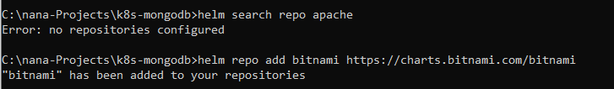

Search the “bitnami” repo to see all charts which it contains

|  |
| --- |
| $ helm search repo bitname |
| **Default syntax: $** helm search repo <repo-name> |

Search for a package (e.g. Jenkins, mongodb, redis etc) in the chart repo

|  |  |
| --- | --- |
| Default syntax | $ helm search repo <repo-name>/<package> |
| Search for the package “mongodb” in the repo “bitnami” | $ helm search repo bitnami/mongodb |



Visit bitnami’s github repo for MONGODB and study the nature of the files there

|  |
| --- |
| https://github.com/bitnami/charts/tree/main/bitnami/mongodb |

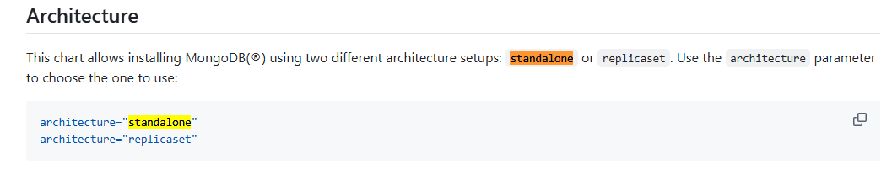

Change the architecture from “standalone” to ‘replicaset’

|  |
| --- |
| architecture: replicaset  replicaCount: 3  auth:    rootPassword: secret-root-pwd  persistence:    storageClass: "managed-csi-premium"    size: 8Gi |

Do this before running the command below.

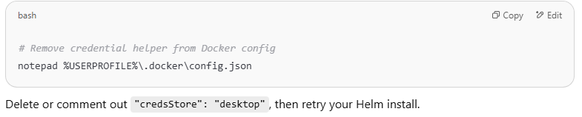

To install this, run

|  |  |
| --- | --- |
| Default format | $ helm install [our name] –values [values filename] [chart name] |
| Sample to run | $ helm install mongodb --values test-mongodb.yaml bitnami/mongodb |

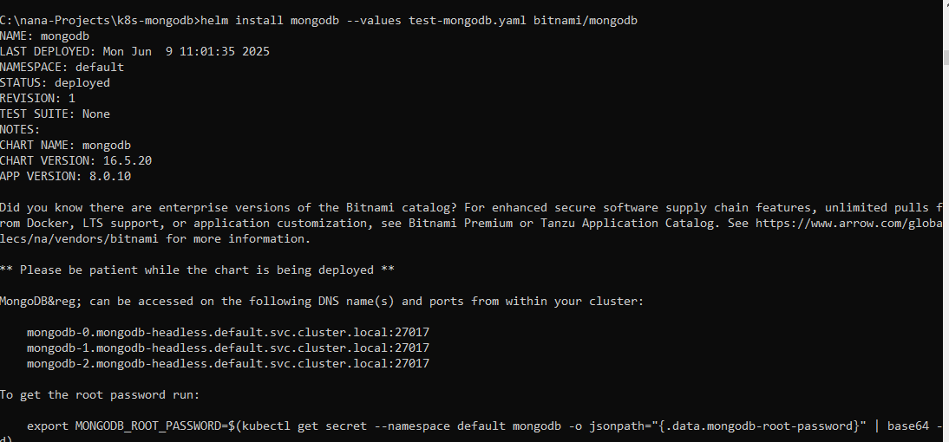

View all of what got created

|  |
| --- |
| $ kubectl get all |

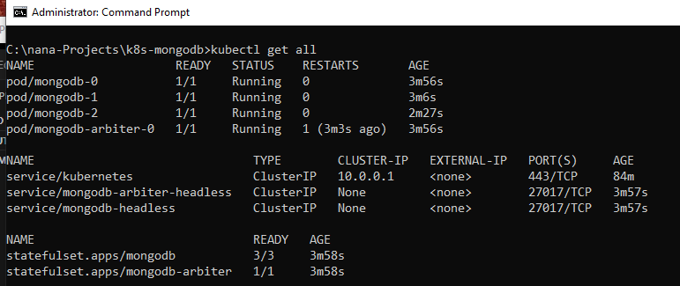

View the created secrets

|  |
| --- |
| $ kubectl get secrets |

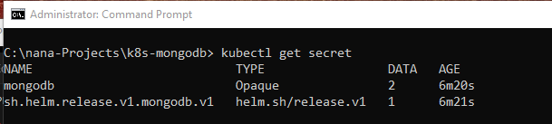

As a result of this deployment, 03 PVC were created as shown in the azure portal.

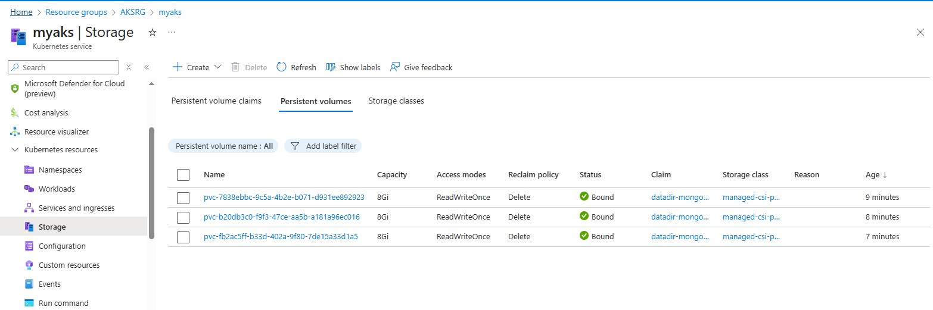

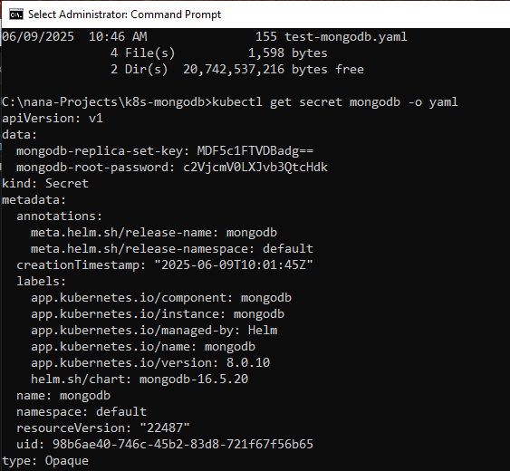

Apply the deployment

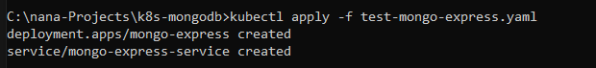

Add a repo to install the nginx controller. Let’s use the **bitnami** repo.

|  |
| --- |
| helm install ingress-nginx bitnami/nginx-ingress-controller --set service.type=LoadBalancer --set controller.publishService.enabled=true |

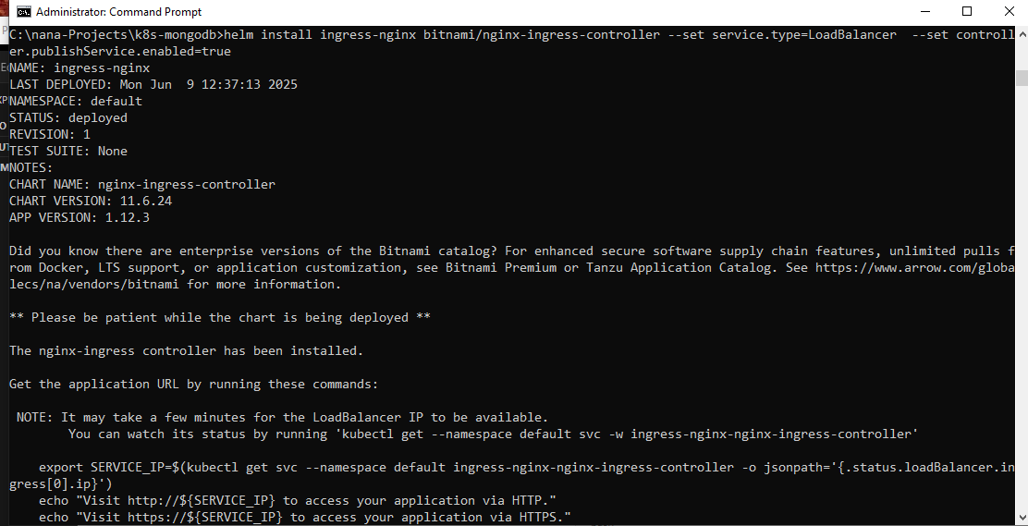

Uninstall helm chart

